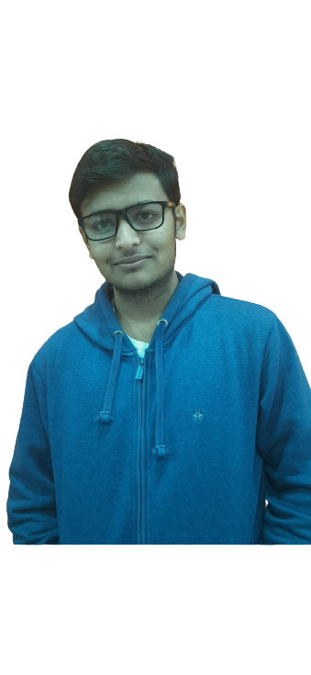okya

***Education: -***

***Class 10th: -***

**Ryan International School, Indore**

**Percentage: - 81%**

***Class 12th: -***

**MVM, Indore**

**Percentage: - 76%**

***B-tech (CSE specialization in AI and ML): -***

**Vellore Institute of Technology BHOPAL**

**Current CGPA: - 8.1**

***About Me: -***

I am a very passionate person and always like to experience new thing, I have a positive mind set and never look back down from any challenge, one of the most impressive qualities that I have is that I get easily blend with people around me which make me a good team worker and also have good leadership skills, and I am hard-worker and take my work seriously.

***Experience: -***

* I have worked as a full stack web developer in the program organized by the nullclass for 3 months.
* I also done a course from Internshala for the language C and C++.
* Created multiple projects using python and R for AI and ML.
* Have also some experiences in java programming language
* Programming languages: -
* **Python and R**

(For the ML AND AI)

* **C++ and C**

(For the development and programming)

* **Java**

(For the development and programming)

* Web development: -
* **React-Js**

(For Backend)

* **HTML, CSS, JS**

(For Frontend)

* App development: -
* **Flutter**

(For both android and ios)

* *SKILLS*

SKILLS

6263288708

[prakhar.nagar2003@gmail.com](mailto:prakhar.nagar2003@gmail.com)

Indore, MP, India

PRAKHAR NAGAR